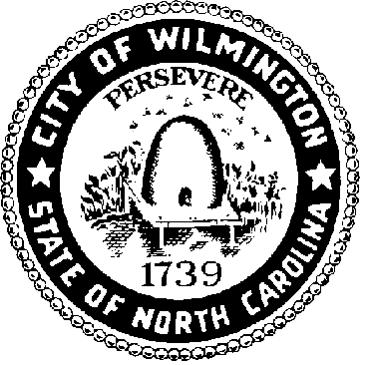

SOCIAL DISTRICT ADVISORY COMMITTEE
April, 1, 2026, 2pm
Skyline Center Azalea Conference Room
Agenda

- Call Meeting to Order

- Approval of Meeting Agenda

- Member Introductions

- Social District Advisory Committee Orientation

- Review of Six-Month Pilot Program in the Brooklyn Arts District (BAD) Social District
  - Information/ reports from Brooklyn Arts District Collective on the BAD Social District
  - Presentation of city staff information/ reports by city department members

- Public Comment

- Consideration of Request by BAD Social District to Continue and Expand Social District Days

- Next Meeting: Wednesday, July 15, 2026, at 2pm

- Adjourn

Hybrid Meeting: Time: Apr 1, 2026 02:00 PM Eastern Time (US and Canada)
Join Zoom Meeting
https://zoom.us/j/97441430372?pwd=GqWGWpnb1oKxF2JThRarwPNWv6Wi5g.1
Meeting ID: 974 4143 0372
Passcode: 262207
One tap mobile
+16469313860,,97441430372#,,,,*262207# US
+19292056099,,97441430372#,,,,*262207# US (New York)
Join instructions
https://zoom.us/meetings/97441430372/invitations?signature=RO1TuodCYEhO3DkVtPLJoGnPHCCdsseO88n2qtmHET8

