NOTICE OF PROJECT

COUNTY OF NEW HANOVER

MULTI-FAMILY HOUSING 2346 CAROLINA BEACH RD., WILIMINGTON

This notice hereby provides the public a minimum 10-day review period beginning July 7, 2025 to submit their concerns and comments. All persons are invited to present their concerns regarding the Starway I/II Project at 2346 Carolina Beach Road (U.S. Highway 421) in Wilmington, New Hanover County in writing or via email. Please submit comments to Jeff Royal via email at NCORR.PublicComments@ncdps.gov or mail to NCORR PO Box 110465, Durham, NC 27709, Attn: Jeff Royal or Tracey Colores.

**Project Description**: The Starway I/II Project is a 278-unit multi-family development in New Hanover County, North Carolina. The units will be within seven buildings and include two playgrounds, a clubhouse, one pool, parking spaces, and two stormwater detention ponds. New Hanover County is a HUD-identified Most impacted and Distressed county from the impacts of Hurricane Florence. The Project received an approved application through NCHFA’s 4% Low Income Housing Tax Credit (LIHTC) program under the 2021 Qualified Allocation Plan (QAP). The purpose and need of the proposal is to provide quality, affordable housing opportunities to low- to moderate-income families and others in an area that need it. Demand for low- to moderate-income and market-rate housing is driven by a lack of affordable housing in this area of Wilmington. Two rental properties are affected (one 2-BR, one 3-BR) and were demolished in order to construct the 278 1, 2, and 3-BR units of the Starway I/II Project.

**Project Source of Funding**:

HUD funding via NCORR (CDBG-DR) = $9,000,000.00

Bank Loan = $25,816,088.00

City of Wilmington (ARPA) = $3,500,000.00

Federal LIHTC = $28,546,647.00

New Hanover County Loan (ARPA) = $1,896,698

Estimated Total Project Cost [24 CFR 58.32(d)] = $68,759,433.00

**Project Location**: The project area site is located at 2346 Carolina Beach Road (U.S. Highway 421) in Wilmington, New Hanover County, North Carolina 28401. This project area is comprised of approximately 15.67 acres consisting of the following four contiguous tax parcels: R06013-021-001-000 (12.76 acres), R06018-002-006-001 (1.16 acres), R06014-001-001-000 (1.03 acres), and R06014-001-004-000 (0.72 acre). Maps of Demolished Properties and Project 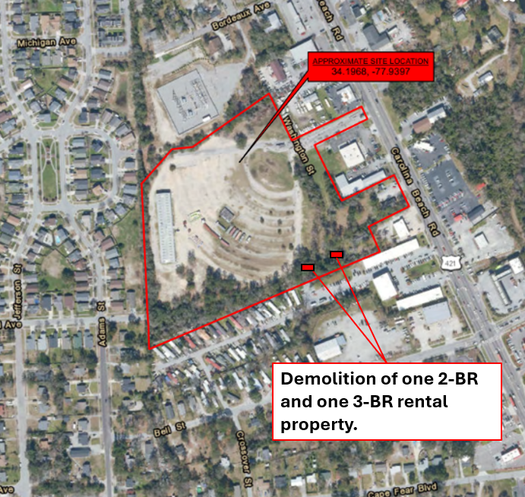Location:

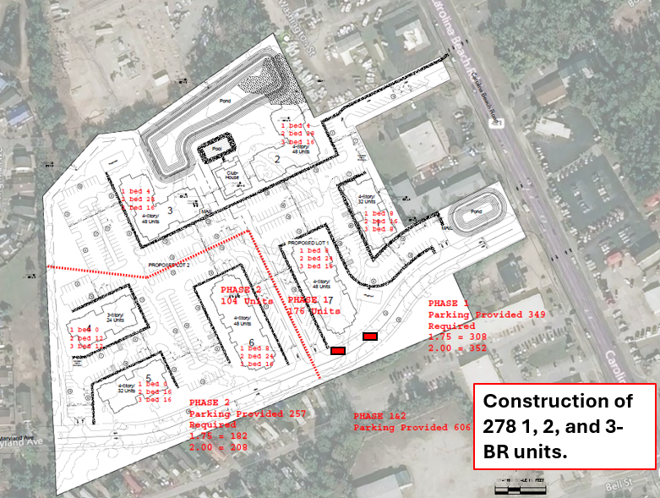

**Project Timetable**: Demolition of the two rental properties is complete. The construction of the 278 multi-family units is underway and expected to be completed between late September 2025 and January 2026. The applications for leasing these units are currently available for Phase 2 and will be available later in the late summer or early fall for Phase 1. For information on applications, the external property management company can be reached at 910-222-3813.